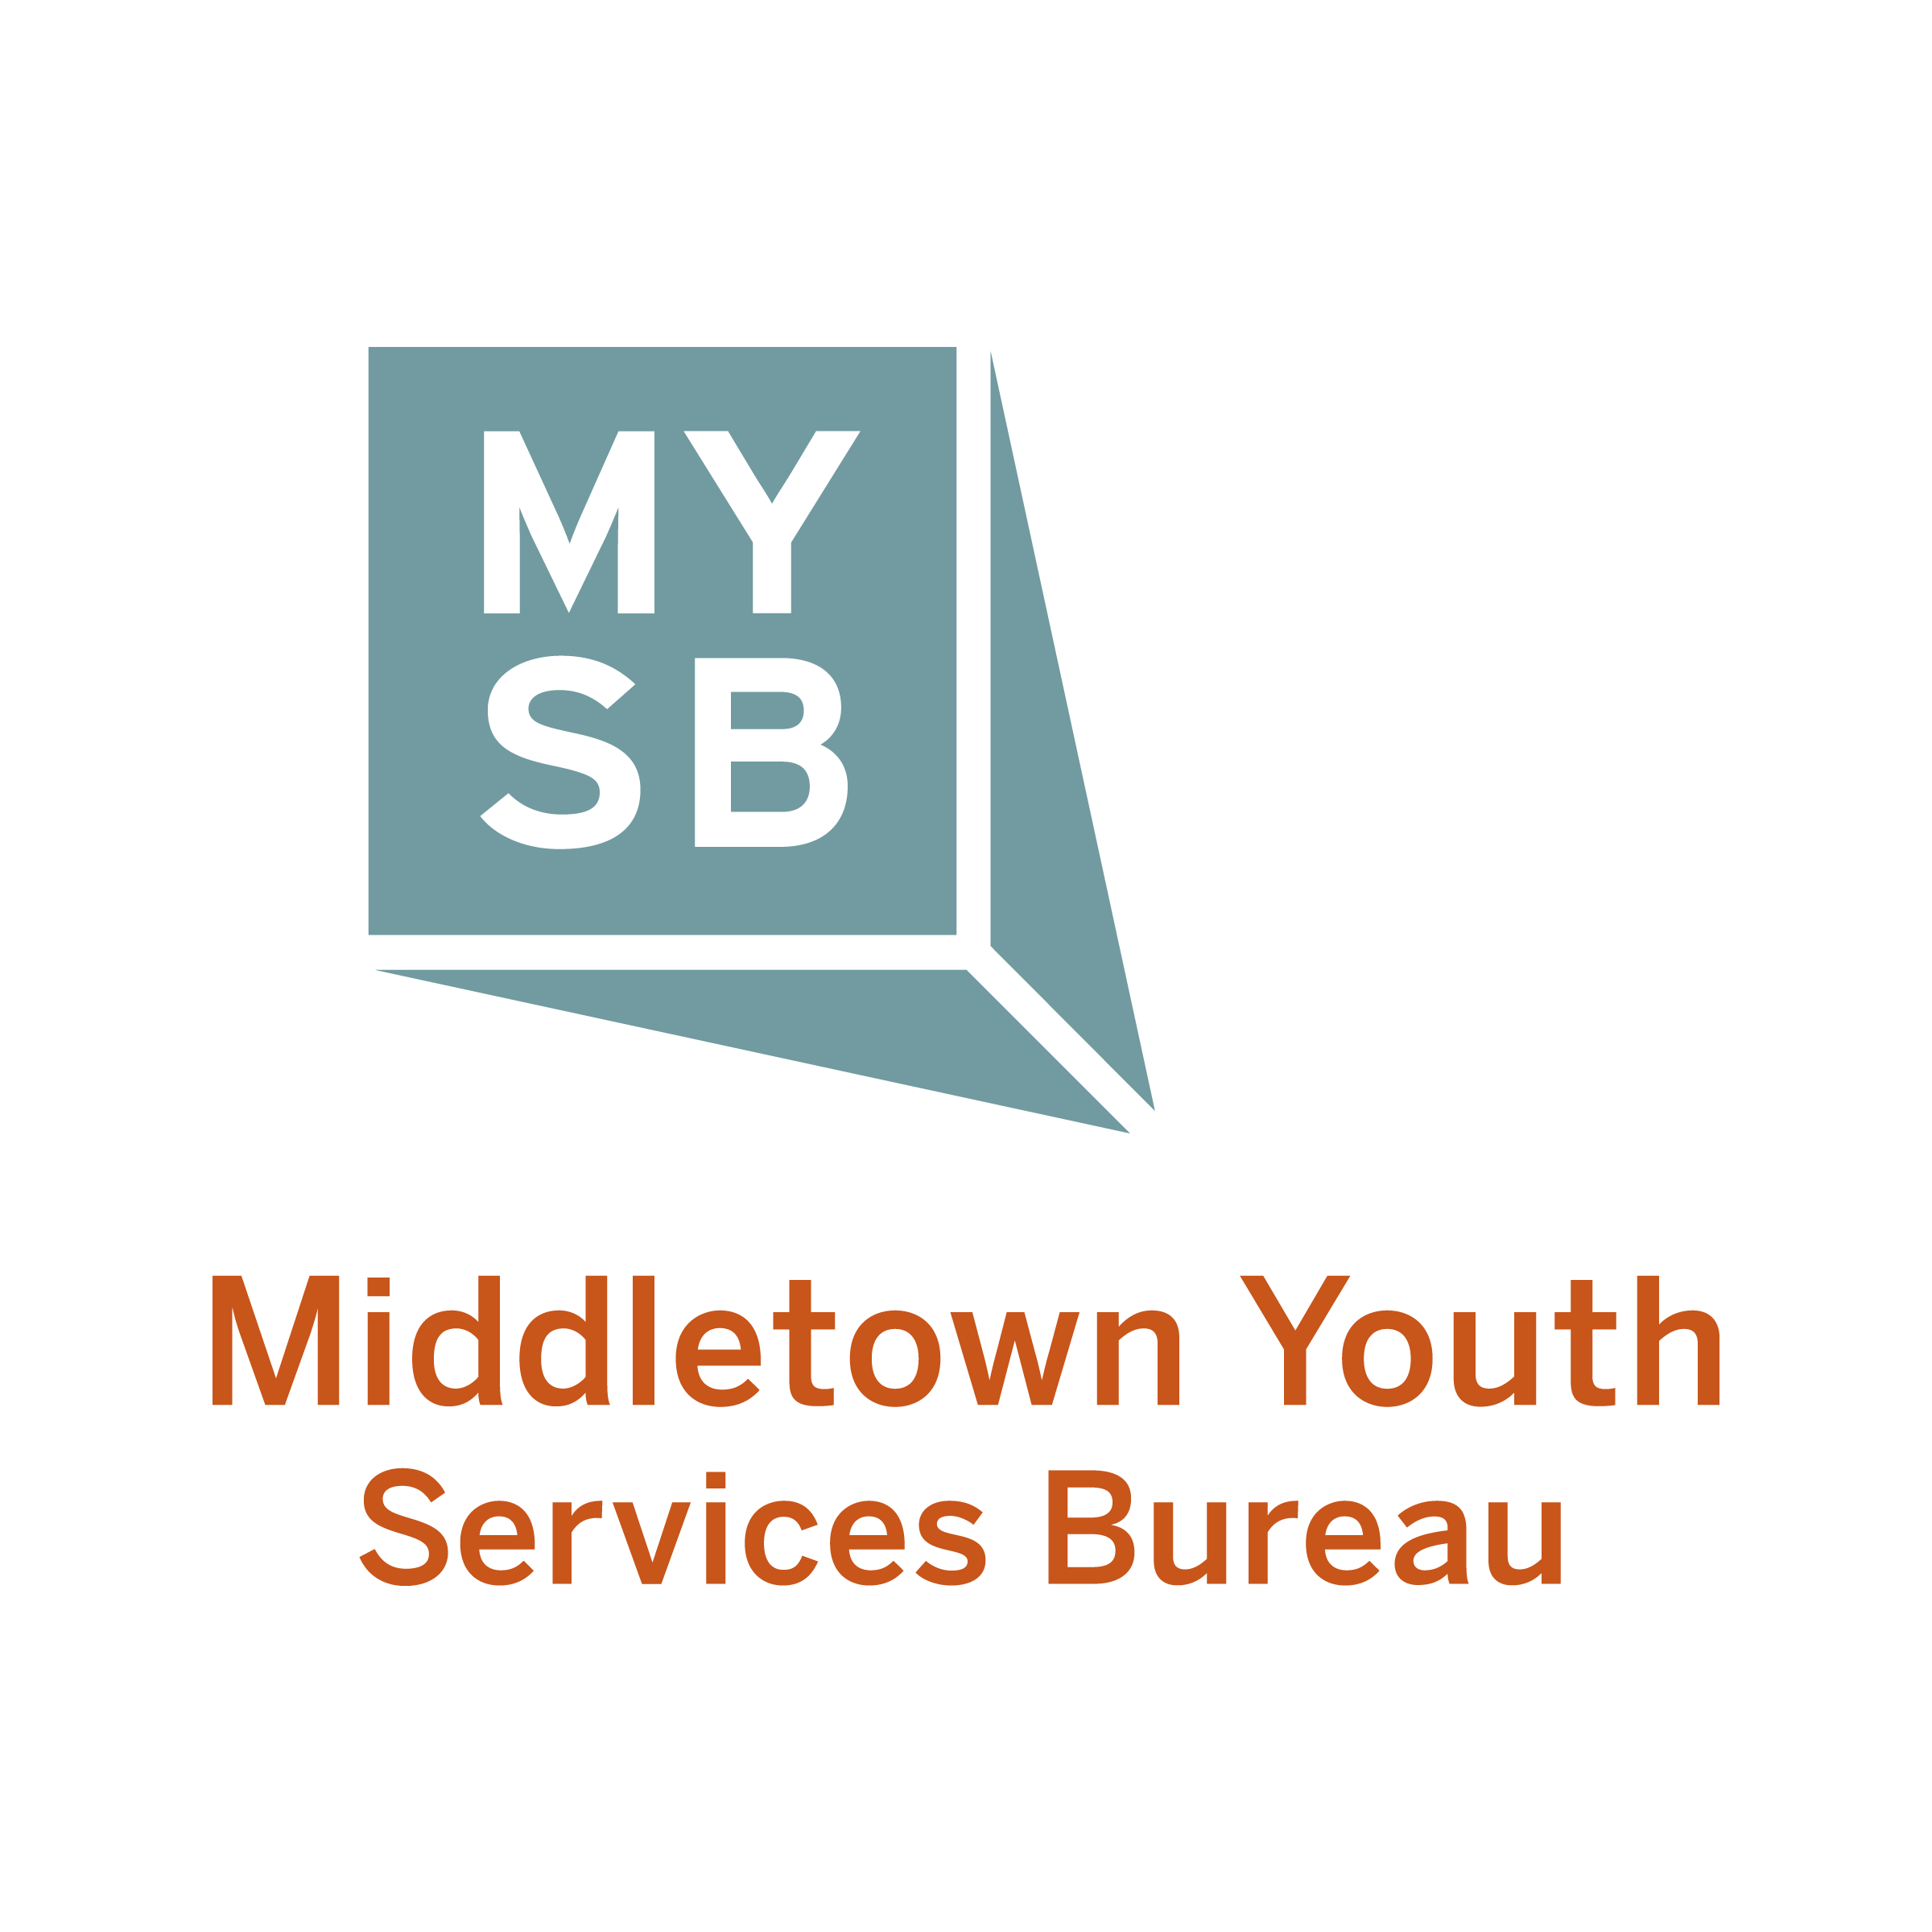
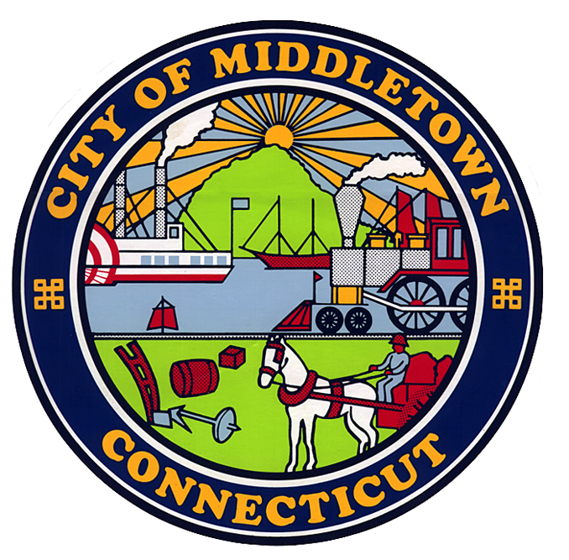

Request for Proposals
Educational Incentive Challenge Grant
Fiscal/Program Year 2025 – 2026

August 18, 2025
Dear Friends,
As we enter another program year please know that I am in full appreciation of the role that positive youth development programs play in young people’s lives here in Middletown. By creating environments of love and learning; by providing them relationships, skills, & security; and constructing safe outlets for creativity and risk taking, you provide opportunities and support that they may not find anywhere else in their lives. Thank you for your contributions to the creation of these ever essential spaces and places here in Middletown. Our young people are better off because of your work.

With that, the Common Council has approved $30,000 in the City’s budget to help support afterschool programming. The Youth Services Bureau Advisory Board, who facilitates the process on behalf of the City, will continue to place extra emphasis on both qualitative and quantitative measures that can indicate program success through measurable outcomes as they work to distribute funds.

As a reminder, this Request For Proposals (RFP) is to solicit program activities from community agencies and organizations that support the goals of the Educational Incentive Challenge Grant. This grant is looking to fund program activities for children in Grades K-12 that help support under-resourced and under-represented students who traditionally are not involved in programming outside the regular school day. These activities may be of academic, recreational, cultural, physical, psychological, and/or emotional benefit to the child. Attached please find guidelines, timelines, and directions for the narrative that will assist you in the development of your proposal.

On behalf of the City of Middletown and its Youth Services Bureau, thank you for your interest in serving and improving the lives of our children and youth.

Regards,

Justin Carbonella, MPA,
Youth Services Coordinator
Educational Incentive Challenge Grant Guidelines

(bolded text denotes adopted changes by the Common Council on 7/7/14)
The following are guidelines for the 2025-26 Educational Incentive Challenge Grant:
- This is a “challenge grant” of which the agency must show matching funds to be awarded the grant. The source of agency funding that serves as the match to potential grant funds (a 1 to 1 ratio – Agency to Challenge) may come from, but is not limited to, the following:
  - Private donations
  - Corporate and business sponsorships and gifts
  - State and federal grants
  - Foundation support
  - Parent Fees
  - College and university financial support

- Any organization placing a grant request of $5,000 or more is required to provide a 1 to 1 ratio match.
- Organizations with total budgets of $75,000 or less, may apply for “match-free” grant if the request is between $1,000 and $4,999.
- Organizations with budgets over $75,000 may petition the Youth Services Bureau Advisory Board via email by noting the circumstances and why they are requesting to qualify for a $1,000-$4,999 “match-free” award. Please allow for a 72 hour (business day) response time.
- In-kind donations WILL NOT count towards the match.
- Maximum grant will be $10,000; minimum grant will be $1,000.
- Funding will be granted on a one-year basis only with all funds expended no later than
May 30th of the fiscal year.
- Programs must offer open enrollment to all children – preference will be given to programs that recruit the target population of under-resourced and under-represented students who traditionally are not involved in programming outside the regular school day.
- Programs cannot be for the purpose of religious instruction.
- Programs will be asked to give a short 7-10 minute presentation and be open to questions from the Youth Services Bureau Advisory Board on Tuesday, September 16th beginning at 6 pm (please mark that evening in your calendar in advance). Time slots will be assigned after successful submission of a grant; with notification to follow no later than September 9th.
- Programs must show proof of liability insurance.
- Successful grantees will complete a contract, file quarterly reports, attend youth development training, and will be asked to accommodate site visits from the Youth Services Bureau.
- Successful grantees will be asked to track a series of standardized youth development outcomes.
- This is a reimbursement grant. Reimbursement payments will be issued quarterly upon receipt of proper reporting forms accompanied by the receipts for all expenses listed. Reporting forms and receipts will be reviewed, verified and approved prior to reimbursement being issued.

Funding Timeline

RFP Submission Deadline: Friday, September 12th, By 4 p.m.
Presentations to YSBAB: Tuesday, September 16th, 6 p.m., in person
Expected Common Council Approval: Monday, October 6th, 7 p.m.

The YSBAB will only be accepting digital submissions. Final versions of your proposals should be sent to Justin.Carbonella@middletownct.gov and must be in said inbox by 4 p.m. on the day of the deadline.

Location of the Sept YSBAB meeting will be TBD but you will get confirmation on 9/12 after submission of your grant along with a final meeting agenda and presentation order. The order of presentations will be determined by the order in which proposals were received (e.g. first submission will be the first presentation).

For any questions, please contact:

Justin Carbonella
Email: Justin.Carbonella@middletownct.gov
Phone: 860-638-4530

City of Middletown
Youth Services Bureau

EDUCATIONAL INCENTIVE CHALLENGE GRANT

GRANT COVER PAGE

Applicant/Agency: _ ____
Program Name: __________________________________________________________________

Amount of Grant Funding Requested: Amount of Cash Match:

Grant Contact Person: ______ _______________________________

Grant Contact Phone/Email: _______________________________________________

Program Contact Person: _________________________________________________

Program Contact Phone/Email: _____________________________________________

Agency Address: _____ _________________________

Town, State & Zip Code: _____ __________________________

The undersigned authorized chief administrative official submits this proposal on behalf of the applicant agency, attests to the appropriateness and accuracy of the information contained therein, and certifies that this proposal will comply with all relevant requirements of the city, state, and federal laws and regulations.

In addition, funds obtained through this source will be used solely to support the purpose, goals and objectives of the City of Middletown Educational Incentive Challenge Grant. The following signature is required:

Agency Director/CEO/
Authorized Official Signature:
(signature can be either hand signed, scanned, and sent or can come via signee’s direct email address)

Name (typed): ______
Date:

Proposal Narrative

Limit to ten (10) pages (excluding Cover Page). Use these headings and numbers when drafting your document. All documents must be typed in twelve (12) point font. Please put your agency’s name on all pages. Electronic Submissions Only. Thank you.

Top Sheet - Cover Page

- Standard information about the agency, including: mission, history, primary activities, present work/contracts/grants, and population served (age, location).

- Objective(s) of the proposed program, including: target age/grade and skill development, or outcomes that are aligned with the goals of the Educational Incentive Grant.

- Measurable outcomes on how you plan to measure your success as well as recent outcomes on the past year’s (2024/25) measurable outcomes. Please also include a cost per participant ratio (i.e. $10,000 program for 100 students equals a $100 cost per student or $10,000/100 = $100 cost per student).

- Program description including: Statement of community need for program and how the activities are aligned with educational goals for targeted population. The number of children served, number of sessions per week, length of each session, total program hours (as well as a cost per hour per student ratio; program budget/number of students/total program hours), and staff assigned with brief descriptions should be included. Attach curriculum and/or session by session description if available. Please also include any contingency plans you may have that relate to COVID-19, particularly in relation to in-person programming being shut down.

- Priority Areas have been identified by members of Middletown’s Mayoral Youth Cabinet. The following priorities must be addressed as part of the narrative. Please identify one of the following areas that your program incorporate as part of your ongoing programming. Please include both actionable items and how they will be measured. The areas to select from are:

- Ensuring each Middletown youth has strong developmental relationships with at least 3 adults in their life. See Search Institute’s “Developmental Relationships” model as an example here.

- Creating a community that better understands and empathizes with young people; free of stereotypes and judgement. This will allow youth to grow up in a community that is prepared to support their hopes and dreams for both themselves and their community.

- Supporting youth mental wellness. Beyond just awareness of mental health issues, youth need skills to build up their wellness and resiliency to internal and external stressors.

- NEW: Life Skills. Provide youth key life skill development from any of the following areas; social and emotional regulation, financial literacy, and/or, soft skills/social skills/relational skills.

- Intended location and how participants safely arrive and depart from the program.

- Need from sponsoring organization and description of program goals for which funds are being requested. Please be explicit on what funding will provide and what will happen if funding is not available.

- Itemized budget, to include: costs associated with providing the program described above, staff, materials, travel, etc. Please account for any in-kind contributions that the agency will provide. Clearly identify the 1:1 (Agency: Challenge Grant) ratio cash match and source. Please indicate if this is a new program or expansion of the current program.

BUDGET FORM FISCAL YEAR 2025-26 EDUCATIONAL INCENTIVE CHALLENGE GRANT
GRANT TITLE: EDUCATIONAL INCENTIVE CHALLENGE GRANT
PROJECT TITLE:

GRANT PERIOD: 07/01/2025 – 06/30/2026 REQUESTED AMOUNT:$

CODES | DESCRIPTIONS | EDUCATIONAL INCENTIVE  BUDGET AMOUNT | CASH MATCH | IN-KIND
100 | STAFF SALARIES
200 | PERSONAL SERVICES/EMPLOYEE BENEFITS
300 | PURCHASES PROFESSIONAL/TECHNICAL SVCS
400 | PURCHASED PROPERTY SERVICES
500 | OTHER PURCHASED SERVICES
600 | SUPPLIES
 | TOTAL

BUDGET NARRATIVE - INCOME

Provide a detailed description of the sources and amounts of cash funds and in-kind services to be used for the local match. Line item totals should agree with line items on the Budget Form.
Account Name | Description | Line Item Total
Funds from sources outside of the Educational Incentive Grant – must be 1:1 ratio for the cash match
Cash Match
In-Kind
List source and amounts for in-kind contributions that will be used as match for this grant.

BUDGET NARRATIVE - EXPENSES

Provide a detailed description of the expenses to be funded by the Educational Incentive Challenge Grant. Line item totals should agree with line items on the Budget Form for the requested amount.

Account |  | Line Item
Code/Name | Description | Total

Budget Object Codes
Include all budget account descriptions for the following categories:
100 Salaries
Amounts paid to employees of the grantee involved in providing direct services to pupils/youth. Include all gross salary payments for these individuals while they are on the grantee payroll, including overtime salaries or salaries paid to employees of a temporary nature.
200 Personal Services – Employee Benefits
These amounts are not included in the gross salary, but are in addition to that amount. Such payments are fringe benefit payments and, while not paid directly to employees, are nevertheless part of the cost of personal services. Included are the employer’s cost of group insurance, social security contribution, retirement contribution, tuition reimbursement, unemployment compensation and workmen’s compensation insurance.
300 Purchased Professional and Technical Services
Payments for services performed by persons qualified to assist program staff to enhance the quality of the delivery process. This category includes curriculum consultants, in-service training specialists, etc., who are not on the grantee payroll.

400 Purchased Property Services
Expenditures for services to operate, repair, maintain and rent property owned and/or used by the grantee. These are payments for services performed by persons other than grantee employees. Examples include: rental costs for renting building space or equipment such as copiers, telephones, cellphones, or fax machines.

500 Other Purchased Services
Expenses for services rendered by organizations that are not classified as Purchased Professional and Technical Services or Purchased Property Services. This could include transportation costs for field trips, etc.
600 Supplies
Expenses for items that are consumed, worn out, or deteriorated through use and have an expected useful life of less than one year.

700 Property
EXPENSES FOR THE PURCHASE OF PROPERTY (INCLUDING COMPUTERS) ARE NOT ALLOWED.

